THE PRESIDENT’S OFFICE
REGIONAL ADMINISTRATION AND LOCAL GOVERNMENTS.
LONGIDO DISTRICT EXAMINATION SYNDICATE
FORM TWO HISTORY MOCK EXAMINATION- SEPTEMBER 2019
TIME:2:30HRS
INSTRUCTIONS
- This paper consists with sections A, B and C
- Answer all question in sections A and B and two(2) questions from section C
- All writing must be in blue or black ink.

SECTION A (40MARKS)
Answer all questions in this section
- For each of the following items (i-x) choose the correct answer from among the given alternatives and write its letter in the box provided
- Is the study of all aspects of human life and culture
- Archaeology
- Museums
- Anthropology
- Oral traditions
- East Africans had begun to interact with people of middle East, far East as early as
- 400AD
- 200AD
- 300BC
- 200BC
- Was the first exploitative mode of production to happen in human life?
- Communalism
- Feudalism
- Capitalism
- Slavery
- Homo Eractus lived around;
- 1,500,000 years ago BC
- 1,000,000 years ago BC
- 75000BC
- 500,000BC
- The portuguese fort in West Africa
- Fort Jesus
- Olduvai Gorge
- Elmina castle
- The Kilwa fort
- The effect of European penetration to West Africa was;
- Introduction of Iron industry
- Distortion of the Trans-sahara Trade
- Development of Western Sudan states
- Abolition of Triangular trade
- The dutch settlement was established at the cape in 1652 because;
- The dutch were great racialists
- The Dutch were welcomed by the Khosian
- They wanted to initiate relationships with the British
- They wanted to supply the food stuffs for ships sailing to and from the East Indies
- In evolution of man, the use of tools and bi-pedalism were accompanied by the development of man’s
- Agriculture
- Brain
- Limbs
- Trade
- Which of the following marked the end of portuguese rule in East Africa?
- The coming of Europeans to Africa
- The coming of Sultan Seyyid Said to Zanzibar
- The and falling of coast city states
- The fall of Fort Jesus in Mombasa
- The major cause of Ngoni Migration from South Africa during the 19th Century was;
- The death of Zwangendaba in 1845
- Failure of vassal states to pay tributes
- Population pressure leading to scarcity of resources such as fertile land and pasture
- Expansion of trade especially Trans-saharan trade
- Match the items in List A with those in List B by writing the correct letters against the corresponding question number in the table provided;
LIST A | LIST B
(i)A prominant explorer who discover America and the Caribbean | A)Natal transvaal
(ii)A science which involves animal husbandly and crop production | B)Achievement of maritime technology
(iii)A scientific metod of determing Archeological material | C)Zwangendaba
(iv)The Boer trek | D)Laibon
(v)The leader who led Ngoni group to settle in Ufipa | E)Christopher Columbus
(vi)A reasons for the portuguese conquest of the Coast | F)Vasco Da Gama
(vii)A trader and explorer who moved around South Africa and arrived in India in 1497 | G)Carbon 14
(viii)A factor which helped the traders to come to East Africa | H) Abolition of slave trade
(ix) Primitive communalism | I)Agriculture
(x) A maasai political and religious leader | J)Museum
 | K)Ngoni
 | L)Exploration
 | M)Zwanazaba
 | N)A type of social organisation in Africa

LIST A | i | Ii | iii | iv | v | vi | vii | viii | ix | x
LIST B

- Write T if the statement is correct or F if the statement is not correct in the space provided
- Pottary, Basketry and fishing are types of hand craft industries ....................
- Africans did not believes in gods before the coming of missionaries ................
- Zimba and Segeju fight against the portuguese ...........................
- Civil war was among the causes of Ngoni migration ...........................
- Archeology is the source of History which deals with excavation .......................
- Age is the average difference of age between children and parents ...................
- The Nok culture in West Africa was famous in Iron smelting ........................
- The Northern route during the long distance trade in East Africa was controlled by Nyamwezi ...........................
- Kondoa Irangi a historical site in West Africa with paintings and drawings in caves ........................
- Oral traditions in the method of collecting information through talking and listening ...........................
- Briefly explain the following terms
- Feudalism
- Slave trade
- Historical sites
- Carbon 14
- History

SECTION B (30MARKS)
Answer All questions in tthis section
- Arrange the following sentences in a chronological order by writing their Roman numbers in the table provided.
- British abolish slavery at the cape which led the Boers to trek
- They come in South Africa during 1652 under the leadership of Jan Van Riebeek.
- They turned the KhoiKhoi into slaves who works in their farms
- They establish new republics such as transvaal, Orange free state and Natal
- First British Occupation of South Africa was in 18th C.
Answers
Ist | 2nd | 3rd | 4th | 5th

- Complete each of the following statements to correct historical
- The land owners during the feudalism were known as ......................
- Trans-Atlantic trade is also known as ..........................
- .................... was a socio-political and economic system based on age groups as the basis for the division of labour in the society.
- ..................... Is the act of selling and buying human as commodity
- A leader of Dutches who settled at the Cape was known as ...........................
- Study the sketched map of East Africa below and name the Historical sites shown.
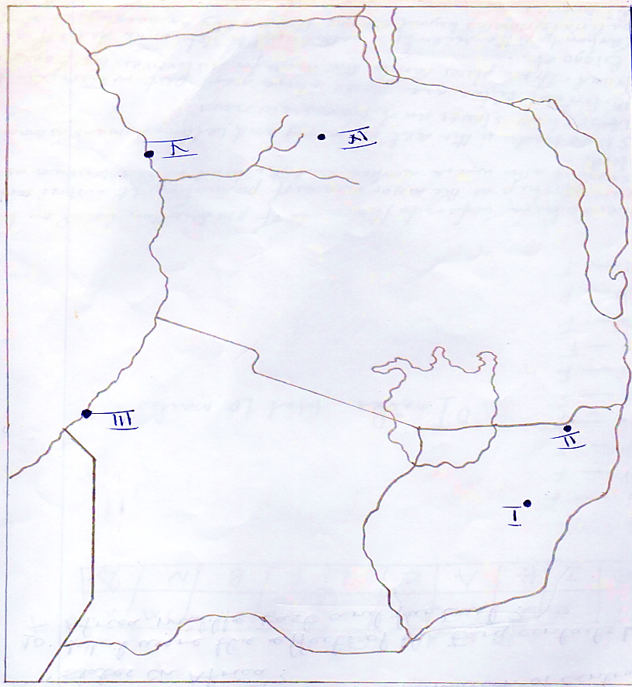

SECTION C (30MARKS)
Answer two (2) questions from this section.
- What were the effects of the discovery of fire during the Middle and late Stone Age? (Give six points).
- Which factors gave to the formation of centralized states in Africa?
- What were the effects of the Early contacts between Africa, middle East and Far East?

